Name:- zeyad mohamed dawood

Section:- 3

Answers of task one of assemply:-

Q1:--

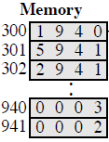In the Hypothetical Machine the contents of memory was as shown. And PC contents is 300. Show the contents of memory and PC , AC , IR after execute three instructions (three fetch cycle and there execute cycle)

A1:-

Load:- pc = 300

Ac = 0003

Ir = 1940

Add :-

Pc :- 301

Ac :- 0005

Ir :- 5941

store :-

Pc :- 302

Ac :- 0000

Ir :- 2941

Q2:--

* Show the contents of PC , AC and IR and memory after the execution of each instruction of the following program on the Hypothetical Machine:
* 300 LOAD 550
* 301 ADD 551
* 302 STORE 600
* Where the contents of memory at 550 is 3 and at 551 is 4.

A2:-

Load:-

300 : 1550 Pc:-300

301 : 5551 Ac:-0003

302 : 2600 Ir :-1550

550 : 0003

551 : 0004

600 : 0000

Add:-

300 : 1550 Pc : - 301

301 : 5551 Ac :- 0007

302 : 2600 Ir :- 5551

550 : 0003

551 : 0004

600 : 0000

Store:-

300 : 1550 Pc :- 302

301 : 5551 Ac :- 0000

302 : 2600 Ir :- 2600

550 : 0003

551 : 0004

600 : 0007

* Q3:-
* The following figure provide the main characteristics of Hypothetical Machine.
* 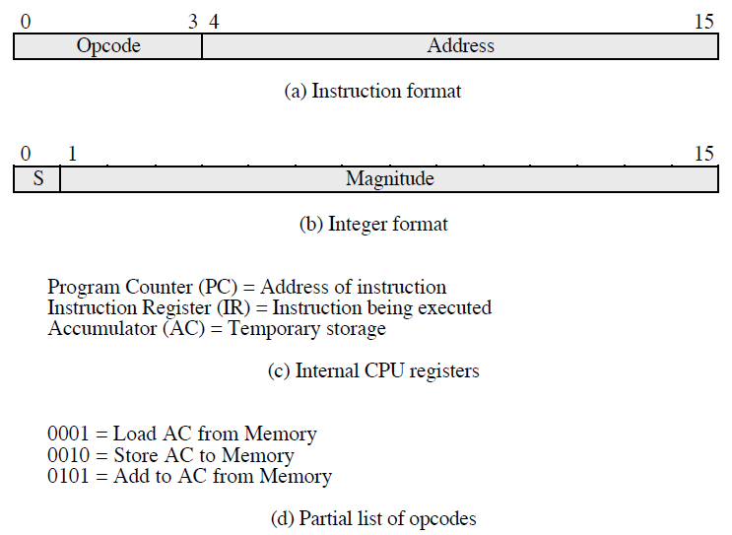

The hypothetical machine also has two I/O instructions:

0011 = load AC from I/O

0111 =store AC to I/O

In these case, the 12-bi address identifies a particular I/O device. Show the program execution for the following program:

1. Load AC from device 5.

2. Add contents of memory location 940.

3. Store AC to device 6.

Assume that the next value retrieved from device 5 is 3 and that location 940 contains a value of 2.

A3:-

300 : 3005

301 : 5940

302 : 7006

Device 5 :- 0003

940 : 2

Device 6 :- 0005